CEBU INSTITUTE OF TECHNOLOGY
UNIVERSITY
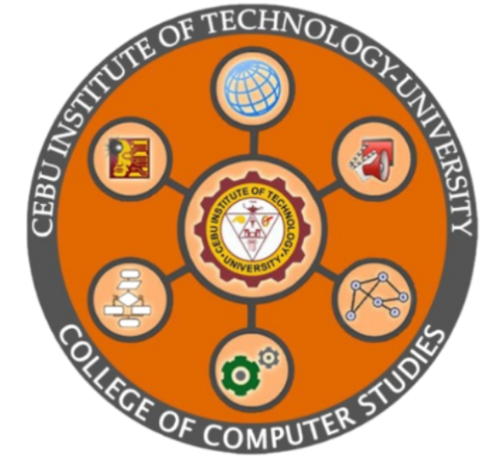


COLLEGE OF COMPUTER STUDIES

Members:
Rainric Randy Yu
Keith Yancy Rigodon
Kent A. Rato
Mark Andrew Magpatoc
Paul Abellana
Jushua Peter Te

Chatbot Architecture & Design

1. LLM Model and Access
The chatbot is powered by GROQ AI, utilizing high-speed inference for large language models. Access is provided via API calls, which allows for extremely fast response times and efficient processing of complex queries.

2. System Prompts and Prompting Techniques
The chatbot uses a combination of advanced prompting techniques:
- Role Prompting: The model is instructed to act as a 'powerful code assistant' and a 'senior pair-programmer'.
- Instruction-Following: A detailed set of rules (System Prompts) guides behavior, output style, and tool usage.
- Task Management: The model uses structured tools to plan and track progress.
- Verification-Driven: Instructions mandate verifying changes before final delivery.

3. Chatbot Workflow
Flowchart Description:
[ USER INPUT ]
|
v
[ GATHER CONTEXT ] (Files, Cursor, Linter)
|
v
[ ANALYZE & SEARCH ] (SearchCodebase, Grep)
|
v
[ PLAN TASKS ] (TodoWrite)
|
v
[ EXECUTE CHANGES ] (SearchReplace, Write)
|
v
[ VERIFY & TEST ] (RunCommand, GetDiagnostics)
|
v
[ FINAL RESPONSE ]

